

**Option 2:**

**Evolution study**

Choose an animal species to create an evolution study on. Research its history, evolution and how it is suited to living in its environment. This could be paper based, iMovie, PowerPoint etc... – be creative!

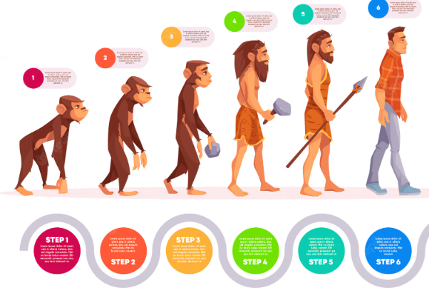

Option 2: Inheritance

Create an ‘inheritance family tree’ to map features (e.g. eye colour and hair colour) of your family members. See how far back you can trace these characteristics to look for any patterns.

**Option** **3:**

**Follow a recipe – adult supervision required**

Linking to our Maths learning around measures and our DT learning about making cookies, can you follow a recipe to bake something of your choice?

Make sure you follow the recipe and accurately measure out all ingredients.

Take photos as you go and make sure you evaluate your final outcome.

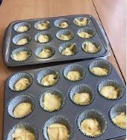



**UKS2 - Homework Web**

**Autumn 2 – Iron Age Hill Forts (History/Geography) and Evolution and Inheritance (Science)**

Please choose 1 of the following projects to complete to help further your knowledge and understanding of this half term’s topics. **Alternatively, if you have a burning desire to complete a different related project, you can surprise your teacher with that instead.**

**Option 1:**

**Create a model hillfort**

Draw or create a detailed Iron Age hill fort. Label the different parts and explain their purposes.

