**Option 3: Create a life cycle for an animal of your choice**

Research the life stages of your favourite animal and create your own life cycle.

This could be in paper form, a slideshow presentation or even a stop motion animation.

Try to include key information about each stage.

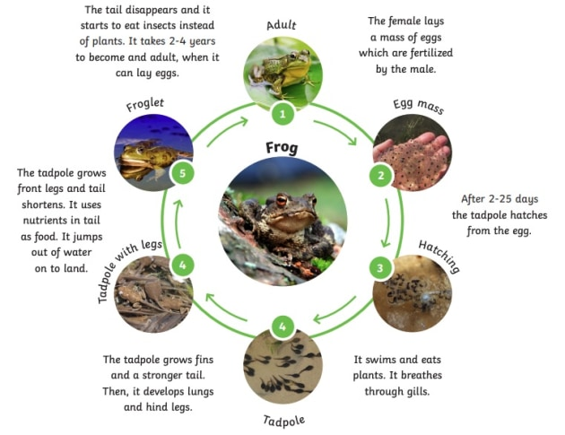

**UKS2 - Homework Web**

**Autumn 1 - Hunter Gatherers**

Please choose 1 of the following projects to complete to help further your knowledge and understanding of this half term’s Hunter Gatherer topic. **Alternatively, if you have a burning desire to complete a different related project, you can surprise your teacher with that instead.**

**Option 1:** **Create your very own Stone Age to Iron Age settlement or Stonehenge model with information**

This could be from any time - caves, huts, hill forts … you choose! You could even include links to some of the resources, objects or hobbies from the time. Material ideas: natural resources, lego, playdough, papier-mâché – it’s your choice.

Add information about your settlement/Stonehenge – labels, where it is found etc…

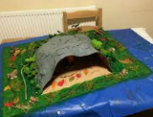 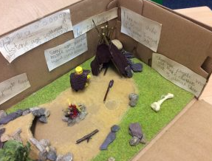

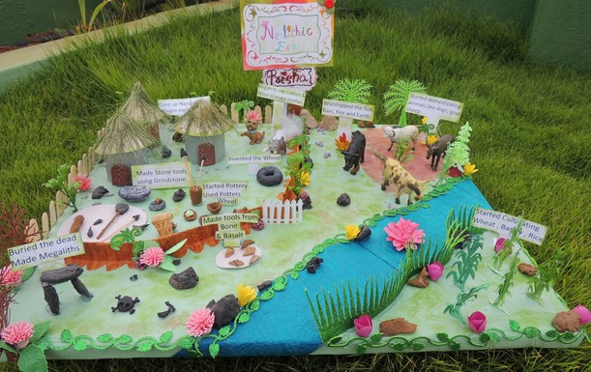 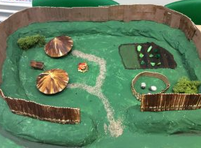

**Option 2: Draw, paint or create a collage of an animal from the Stone Age.**

Choose your canvas – paper, cardboard, cloth – your choice!

You could also find out additional facts about the animal – when it lived, what its diet was, which animal family is it related to…

