

**Year 1 – Option 2 –** Find out about how a material was invented and by who.

Create a fact file about your chosen material and include any interesting facts. 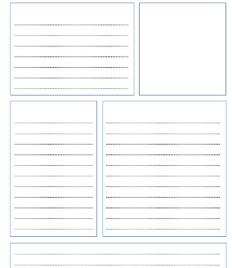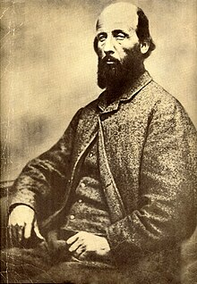

**Year 1 – Option 1 – Junk model using different materials and label them.**

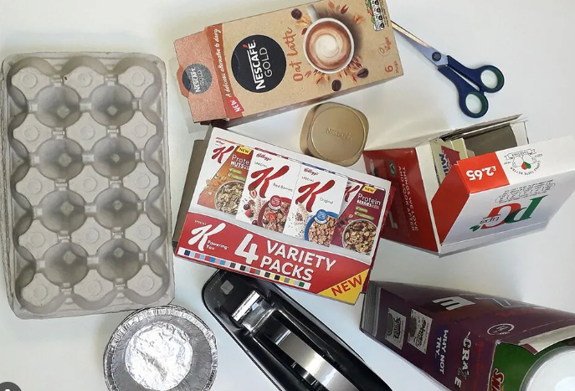 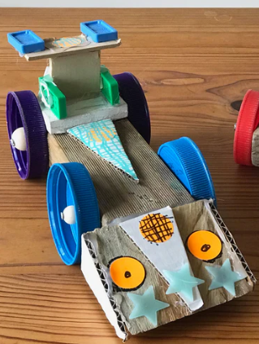

**Year 2 - Option 2: Create your favourite pet.**

Research different pets and choose one to create using junk modelling.

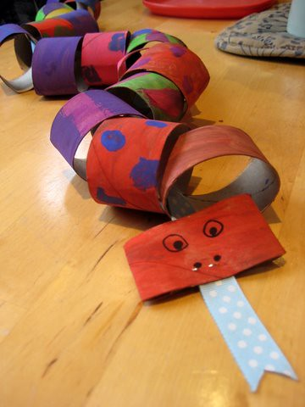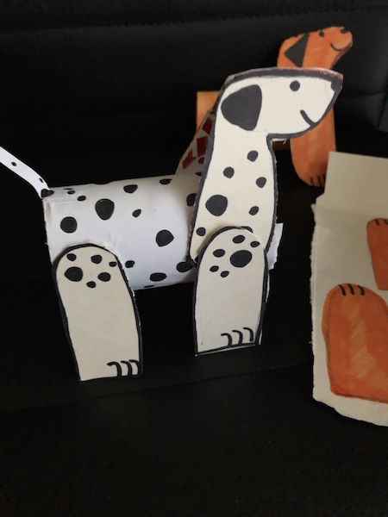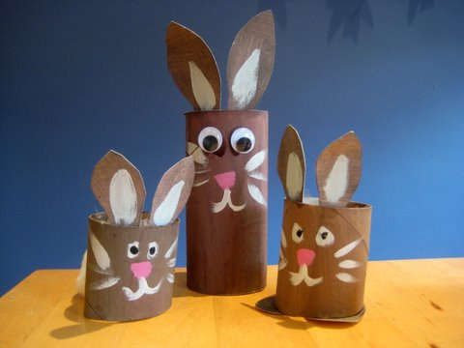

**Year 2 - Option 1:** **Create a model life cycle of an animal including humans.**

Research different life cycles of animals and create a model of one. Use any media you would like, pencils, paints, playdough… Be as creative as you’d like!

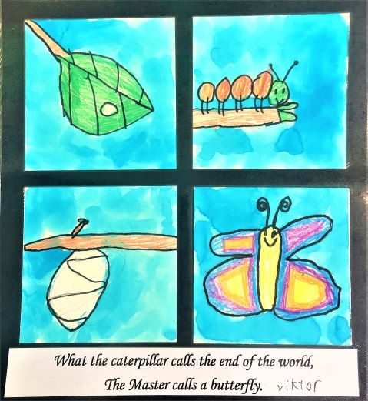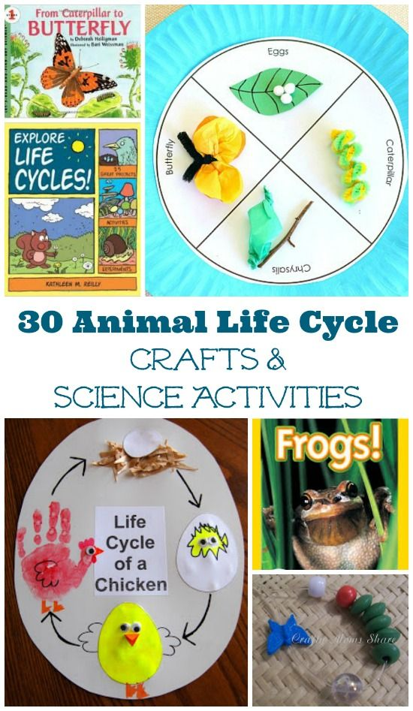

**KS1 - Homework Web – Autumn 2**

**Year 1 Autumn 2 – Everyday Materials**

**Year 2 - Autumn 2 – Animals – survival and growth**

Please choose 1 of the following projects to complete to help further your knowledge and understanding of this half term’s Animals topic. **Alternatively, if you would like to complete a different related project, you can surprise your teacher with that instead.**