

Autumn 2


UKS2 Curriculum Newsletter
Dear Parents/Carers,
Welcome back! The children have been really settled this week and enjoyed an excellent first week back after half term. As always, this half term promises to be a particularly exciting one for children. There will be lots of fun activities to partake in and lots of learning to be done. Please find an outline of this half term’s learning below.

Geography: Map Reading (Hillforts)  Building on our historical learning about prehistoric Britain, will be looking at the geography of the UK. We will use a variety of maps to consolidate our knowledge of the Geography of the UK, both cities and natural features, before studying different hillforts in detail. We will look at OS maps and learn how to read six figure grid references and contour lines. |  | 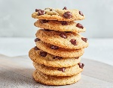  DT:  During this half-term in DT, we will focus on designing, making, and evaluating Fairtrade cookies. We'll begin by researching the concept of 'Fairtrade' and exploring the work of influential chefs who are ambassadors for Fairtrade UK. Children will then taste a variety of cookies and experiment with different recipes. Drawing inspiration from these recipes, each child will design their own cookie, incorporating their own unique ideas. In the final weeks, they will create, bake and evaluate their cookies.
Science: Evolution and Inheritance
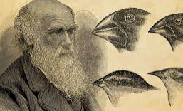
What an exciting half term of Science this promises to be! Children will be learning all about how plants and animals have evolved over time and adapted to suit their environment. They will learn about Darwin’s theory of evolution and natural selection and all about fossils: how they were formed and what they tell us. To further enhance our learning of this topic, we have a very exciting trip to Blackpool Zoo planned where we have a special evolution workshop planned.
PE:  During outdoor PE, the children will be working on ‘Tactics and Strategies’ which can be applied throughout the year. During their indoor lesson, they will be working on developing their ‘Send and Receive’ knowledge.  PE days:  Doves: Wednesday & Friday  Kingfishers: Wednesday & Friday  Eagles: Monday & Wednesday (Swimming kits - this will be our second PE lesson this term) |   RE:  In RE, children will learn about the Muslims within our region. We will learn about the 5 Pillars of Islam and how they support Muslims through their Journey of Life. From this, children will then develop their understanding of two pillars: Charity (Zakah) and Pilgrimage (Hajj). |  | PSHE:  This half term children will be continuing their learning about relationships. In addition to this they will be considering stereotypes and learning how to challenge these, presenting their outcomes as a podcast for the school radio.
Computing:  In Computing, we are focusing on Digital Literacy. We will use Microsoft Excel to create our own databases and graph whilst learning how to use animations and transitions on Microsoft Powerpoint. This will all help us to use technology purposefully to create, organise and store digital content. |  |   French:  The children will learn to follow classroom instructions, such as standing up and opening their books. They will also practice greetings and counting up to twenty, while gaining an understanding of Bastille Day.
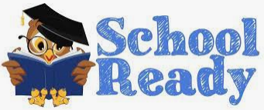  Please ensure your child is always fully prepared for the school day with their school bag, reading record & reading book, homework, and anything else they may have been asked to bring in.  Please can all children bring in an old shirt or t shirt (the bigger the better) that they can wear to protect their uniform during messy activities and Art. |  |   Home Learning:  •Reading 10-15 minutes 5 times per week and completion of reading records  •Completion of spelling activity in homework book. (15mins)  •Completion of arithmetic activity in homework book. (15mins)  •Completion of English activity in homework book. (15mins)  Reading Challenge  5 x= Green; 2/3/4= Yellow; 0/1= Red
  Seesaw  Seesaw is an app we use to track your child’s learning and progress throughout the year. We will send out additional information on how you can view your children’s work as well as how to use this app to share WOW moments from home with us in school |  | X (Twitter) Pages    Each class has a Twitter page which is updated regularly. You can see all the exciting things we have been getting up to in school and how hard the children are working. Please follow us to keep updated!  @GatesDoves  @GatesKingfishers  @GatesEagles

